5E Lesson Plan

Subject area/course/training protocol: What are the students/attendees going to learn?

These lesson plans are created for an 8th grade ELA classroom.
In lesson 1, students will learn about cause and effect and will apply what they have learned to create a Venn Diagram chart comparing a book and movie that we have read and watched in class (Harry Potter and the Sorcerer’s Stone).
In lesson 2, students will learn about different types of communication and how we communicate with each other. This is an introductory lesson that will help provide students with background knowledge needed to meet the 8.31 standard.

Standards (ISTE Standards & State Standards for Students):

ISTE Standards:
1c. use technology to seek feedback that informs and improves their practice and to demonstrate their learning in a variety of ways.
6b. create original works or responsibly repurpose or remix digital resources into new creations.
6c. communicate complex ideas clearly and effectively by creating or using a variety of digital objects such as visualizations, models or simulations.

ALEX State Standards
LESSON 1:
AL.ELA.8.7 - Analyze the extent to which a filmed or live production of a story or drama stays faithful to or departs from the text or script evaluating the choices made by the director or actors.
LESSON 2:
AL.ELA.8.31 – Analyze the purpose of information presented in diverse media and formats (e.g. visually, quantitatively, orally) and evaluate the motives (e.g. social, commercial, political) behind its presentation.

Objectives/Outcomes:
LESSON 1:
- Students will verbalize the importance of knowing how to compare and contrast two things.
- Students will apply the importance of comparing and contrasting to their current and future lives.
- Students will compare and contrast two version of the same story (film and book).
- Students will create a digital venn diagram chart to display what they have compared and contrasted from the book and movie version of Harry Potter and the Sorcerer’s Stone.

LESSON 2:
- Students will verbalize what it means to communicate.
- Students will express the importance of communication in their current and future lives.
- Students will identify the four major types of communication, examples of each type, and best practices to effectively communicate.
- Students will collaborate with peers to create a digital infographic, displaying detailed information about communication.

Differentiation Strategies:
How will the lesson address the various learning styles of the students and the needs of those with special needs?

Varying activities throughout the lesson are implemented to support students of all learning styles. Those with IEPs and 504 plans will have the modifications and accommodations needed per their written plans. Differentiation may include, but is not limited to, modified assignments, additional time, peer collaboration, individual support, language translated materials, materials provided in different fonts or sizes (reading disabilities or vision impairments), etc. Through class discussion, questioning, scaffolding, teacher support, and collaborations with peers, all students should be supported throughout the lesson. Students will have collaborative opportunities in which they can learn from their peers, help each other, etc.

ENGAGEMENT:
Here is your chance to catch the student’s/trainee’s attention. Provide detailed descriptions on two activities utilizing technology to help the students/trainees build on what they already know in preparation for learning something new. Provide a sample of each activity. URLs or screenshots may be needed to show samples. Get the students excited about learning!

LESSON 1: https://padlet.com/audrianaroseee/wuc6kl2ux6dg7xmb
- EXPLANATION: Students will use the padlet found at the link above to brainstorm and discuss what they know about comparing and contrasting. They can read others’ ideas and comment on each other’s’ posts (participate in peer discussion). After all students have completed this activity, we will have a whole group discussion on what everyone thinks comparing and contrasting are and some of their examples of application in their lives.
- SAMPLE: A sample post and additional instructions can be found at the activity per the link provided above.

LESSON 2: https://forms.gle/iwHM3AtJpQogrHA56
- EXPLANATION: Students will use the google form at the link above to briefly share what they know about communication. This will be used to determine understanding and background knowledge. After all students have completed this activity, we will have a brief whole group discussion in which we will share some of our thoughts.
- SAMPLE: the following images include a sample of the online portion of this activity completed.
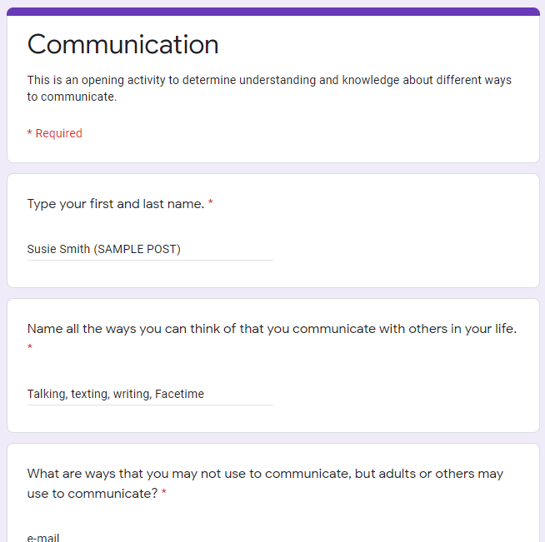
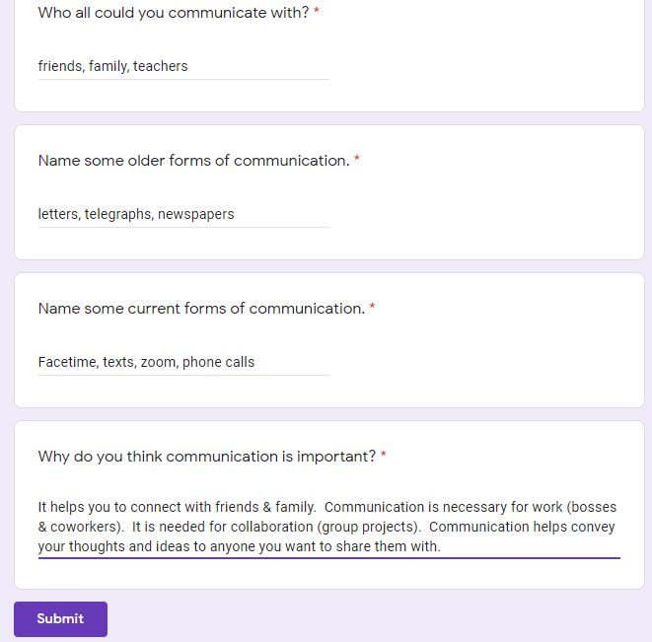

EXPLORATION:
This is it, the heart of learning. Hands-on experiences are mandatory and should include chances for the students/trainees to collaborate and experiment and be able to discuss their learning with others. Provide detailed descriptions of two activities utilizing technology that allow students/trainees to collaborate and discuss content. Provide a sample of each activity.

LESSON 1: https://www.cbc.ca/kidscbc2/content/games/find-the-differences/index.html
Students will play the game found at the link above to find the differences in two pictures. In playing this game, students are comparing the images and will identify the contrasting elements. We will do a think, pair, share after playing the game. Students will be asked what they thought the purpose of the game was. Students will also be asked to discuss elements of images that they noticed as being similar or different from each other. They will think about their answers, pair with a partner to discuss their thoughts, and share what they discussed with the whole class.
- EXPLANATION: Students will look at two very similar, but different images, compare them, and click on the things that they notice are different. This helps students to actively engage by comparing and contrasting different images, notice what elements are similar, and identify the elements that are different by clicking on them. (Students will work at their own pace and can work through as many different levels as they can in 5 minutes).
- SAMPLE: No sample work since this is an online game. I have added a screenshot from the game below.
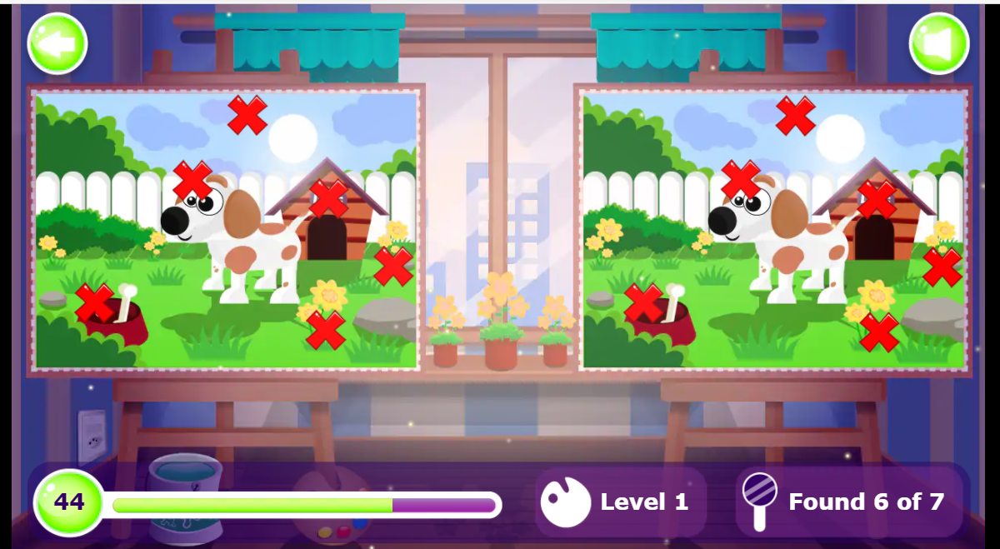

LESSON 2: https://zoom.us/ Zoom Charades.
- EXPLANATION: Students will play charades over zoom (where we can involve both virtual and in person students). A randomizer tool will be used to select who goes first. The person who guesses the correct thing that the actor acts out will get to be the next actor. Only the guessers can talk. The actor must only use motions to act out whatever they choose.
- Randomizer: https://pickerwheel.com/
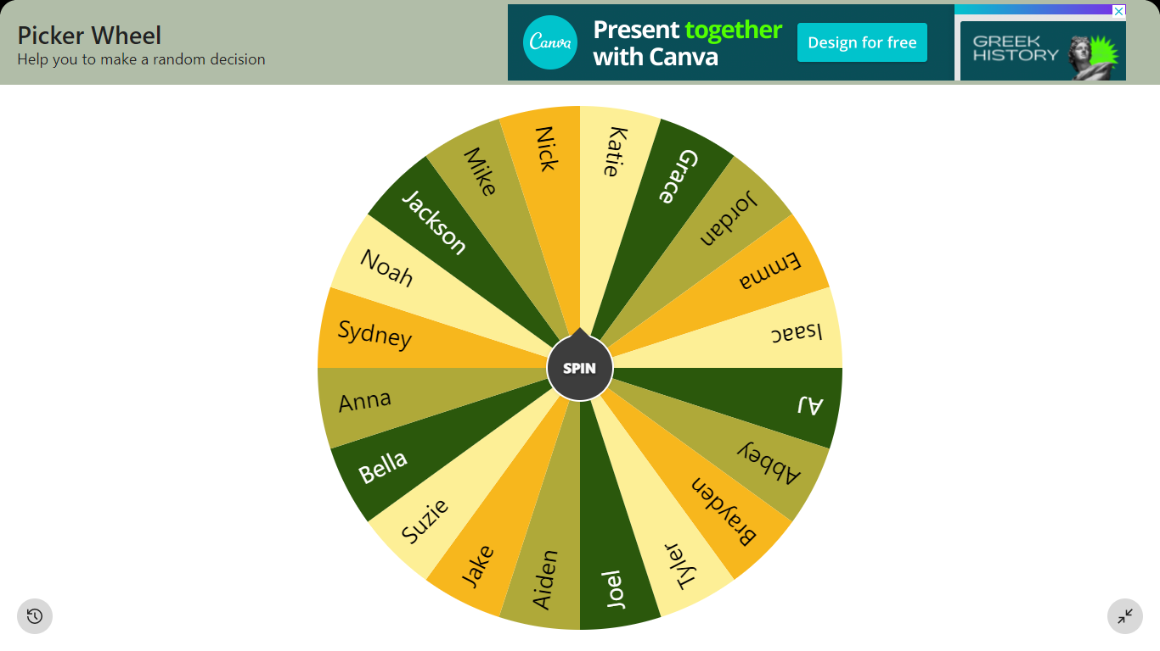
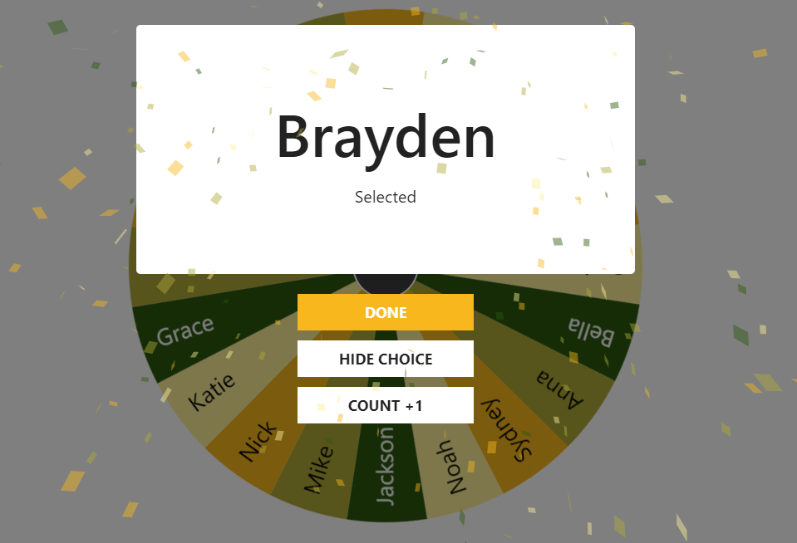
- SAMPLE: Brayden was selected to be the first actor in charades. He chose to act out the word “elephant.” He would hold up one finger to tell the class that he was acting out 1 word. Then, Brayden put his shoulder close to his nose and gently waved his arm up and down (like an elephant trunk). When someone guesses what he is acting out, they get to become the next actor.
After this activity, we will have a brief group discussion on how we communicated with each other during this activity (verbal & nonverbal) and how we could have been better communicators. If students cannot think of ways to improve, I may make suggestions, for example, “I noticed you struggled to share your answer. What made this difficult?”

EXPLANATION:
This stage of the lesson is your part. Clear up any misconceptions from the exploration activity, cover vocabulary, concepts, ideas – whatever is necessary – to help the students/trainees understand the content. Include higher order thinking questions to help the students/trainees connect and comprehend the point of the lesson. Create a presentation using a technology tool other than PowerPoint (or other similar slide makers) to help your students/trainees understand the content; include higher order thinking questions in the presentation.

LESSON 1:
https://www.powtoon.com/s/ccgWTeq3LQe/1/m
After students watch the powtoon instructional video, we will have a whole group discussion regarding the content that includes questioning. Some of the questions used to apply what students have learned and further explore the content may include the following:
- In what ways might you need to compare and contrast things in your life?
- In what ways might you need to compare and contrast things as an adult?
- What changes might you make to the Venn Diagram to help it better display comparing and contrasting ideas.

LESSON 2:
https://www.powtoon.com/s/c5SUcohqNf3/1/m
After watching the explanation video, we would have a class discussion about the video content that also includes various questions to explore the content further. Some of the questions may include the following:
- Based on the video, which types of communications do you use in everyday life.
- What is one type of communication (an example of it) that you saw from the video that you have never used before? How could this type of communication in this specific format be beneficial for you to use in your own life?
- Brainstorming with your partner, is there a type of communication that was not discussed today that you know of? Is there any type of communication that you would like to use that has not been invented yet?

ELABORATION:
This is your chance to plan activities for the students/trainees to apply what they learned in the lesson to their lives and new situations. You will need to be creative and allow your students/trainees to do the same. Design 2 assignments that require students/trainees to create a technology product (webpage, blog, Excel sheet, presentation [NO POWERPOINT/Slide presentations], brochure, etc.) to demonstrate their understanding of the content taught. You must provide detailed criteria and instructions for creating each technology product. One assignment should be a collaborative group project and one an individual product. Provide a sample technology product of each to use as a sample for your students/trainees.

LESSON 1: Venn Diagram Project
Canva Link: https://www.canva.com/
- EXPLANATION: Students will individually create a Venn Diagram using Canva to compare and contrast the book and the movie Harry Potter and the Sorcerer’s Stone. We will have read and watched both adaptations of this story together in class prior to completing this activity.
- SAMPLE: pictured below
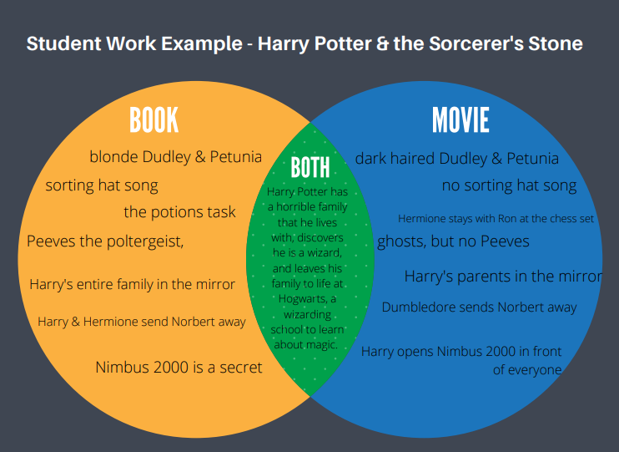

LESSON 2: Infographic Project
Pictochart Link: https://create.piktochart.com/output/53594603-communication
- EXPLANATION: Students will split up into their small groups and will collaborate to make an infographic displaying what they have learned and their further research on communication, ways to communicate information, and ways in which communication can be used to purposefully and effectively convey information.
- SAMPLE: pictured below

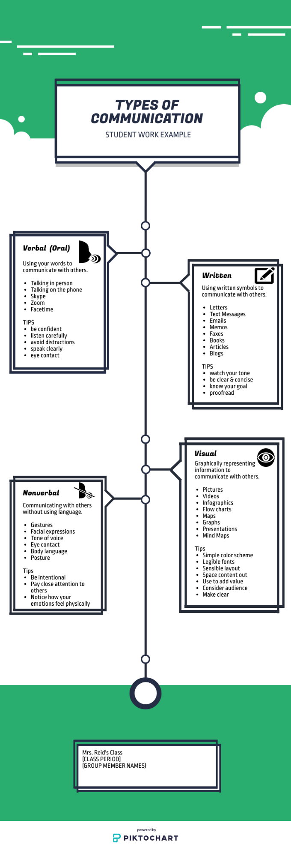

EVALUATION:
Assessment is part of each stage of the 5E lesson plan process. You will need to assess each student/trainee on their participation and understanding and evaluate how close they have come to meeting the objectives/outcomes of the lesson. Explore the following resources to create formative assessments for the engagement and exploration phases. Include these in the appropriate sections on this document.
- Plickers-https://www.graphite.org/app/plickers
- Kahoot-https://getkahoot.com/
- Socrative-http://www.socrative.com/
- Poll Everywhere-http://www.polleverywhere.com/
- You may use other resources

Create a rubric to assess the group projects and individual student/trainee products using a free online rubric maker. Include copies of the rubrics in this section. You should concentrate on standards and objectives, as well as assignment criteria when creating the rubrics. Subject area content should weigh most heavily, as opposed to appearance, grammar, punctuation and mechanics. Be sure to make the criteria in the rubric directly related to the assignment directions and not generic.

Visit the following sites to learn about Rubrics and Checklists:
- Assessment Rubrics http://edtech.kennesaw.edu/intech/rubrics.htm Please read this web site and explore the Sample InTech Rubrics listed.
- Understanding Rubrics http://www.middleweb.com/rubricsHG.html is another good resource for an explanation of rubrics.
- This link http://www.teachervision.fen.com/teaching-methods-and-management/rubrics/4522.html from TeacherVision is the first of a 5 part series in working with rubrics. Be sure to do the other 4 parts.
- Rubistar http://rubistar.4teachers.org/index.php
- Kathy Schrock’s Rubric Page http://school.discoveryeducation.com/schrockguide/assess.html
- Recipes4Success http://myt4l.com/index.php?v=pl&page_ac=view&type=tools&tool=rubricmaker
- iRubric - http://www.rcampus.com/indexrubric.cfm
- Annenberg Learner Build a Rubric - http://www.learner.org/workshops/hswriting/interactives/rubric/
- teAchnology - www.teach-nology.com/web_tools/rubrics/
- You may use other resources.

LESSON 1:
- Engagement: https://padlet.com/audrianaroseee/wuc6kl2ux6dg7xmb The padlet activity will be used to formatively assess students’ background knowledge of comparing & contrasting and how it applies to their lives.
- Exploration: Students will be formatively assessed using the checklist at the following link during their participation of exploration activities to determine if they actively participated and understood activity content (compare/contrast game & discussion) : https://docs.google.com/document/d/1ln38rf0FF_zjmtMId6GQDXzSDyblGdWgApLUUU7eem0/edit?usp=sharing
- https://create.kahoot.it/details/754f9b76-0976-4e82-a077-f53fd70c9987 The link to this kahoot will be used as a tool to check for learning and understanding after the lesson is over.
- The images of the rubric below will be the rubric used to assess the Venn Diagram project.
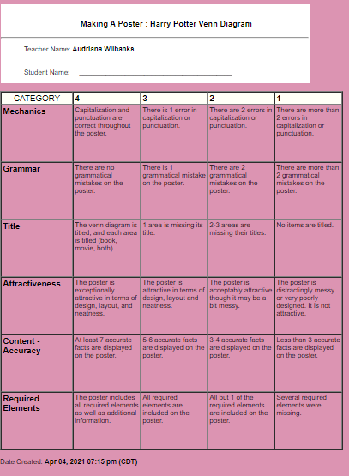

LESSON 2:
- Engagement: The following google form (found at the following link), will be used to formatively assess students on their background knowledge regarding communication. https://forms.gle/iwHM3AtJpQogrHA56
- Exploration: Students will be formatively assessed using the checklist at the following link during their participation and of exploration activities to determine both participation & understanding (zoom charades & discussion after): https://docs.google.com/document/d/1yJpx3AqVnIydvkkE8B6rYBgUClVFNNZAp11eZcoy5hY/edit?usp=sharing

- https://forms.gle/xDH7Uy1pyf7XFEEu8 This google form link above will be used to check for learning and understanding regarding communication after the lesson is over.
- The images below will be the rubric used to assess the group project of creating an infographic.

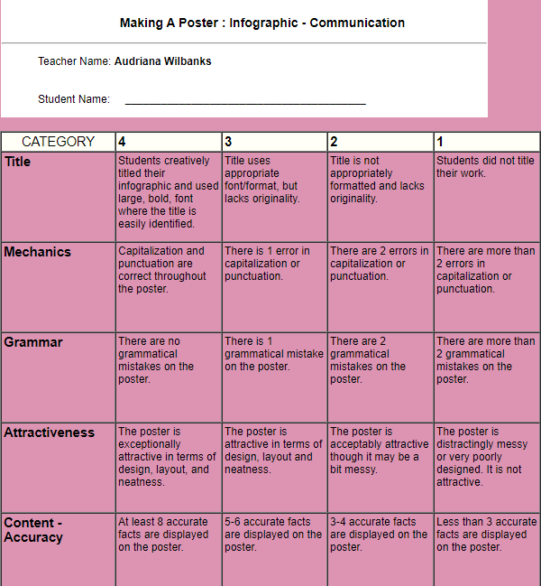

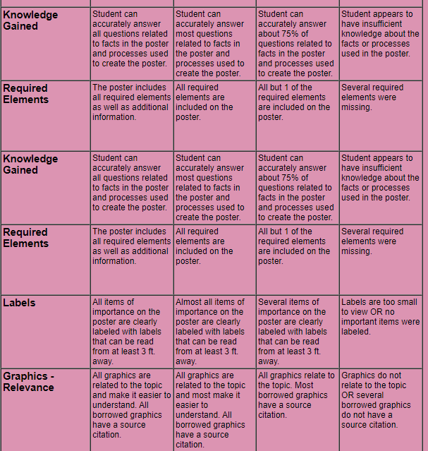
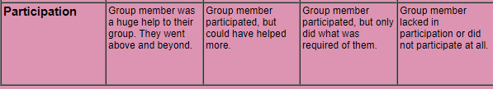

References:
Bybee, R.W. et al. (1989). Science and technology education for the elementary years: Frameworks for curriculum and instruction. Washington, D.C.: The National Center for Improving Instruction.
Bybee, R. W. (1997). Achieving Scientific Literacy: From Purposes to Practices. Oxford: Heinemann.
National Research Council. (1999). Inquiry and the national science education standards: A guide for teaching and learning. Washington, D.C.: National Academy Press.
Polman, J.L. (2000). Designing project-based silence: Connecting learners through guided inquiry. New York: Teachers College Press.

